**Problem Statement:**

**Automatically assign tickets in CRM tools to a particular team**

Currently, queries received to iNeuron team get resolved through Skype which is not efficient as query needs to be assigned manually to iNeuron team members. So, in this project, we will be automating the query resolution system by creating a model that automatically detects the query type, provide the resolution itself if it's a frequently asked query and assign it to the correct team if it’s not able to provide the resolution.

**Objective:**

Objective of the document is to provide a brief overview of the technical architecture of the model of the chatbot which will be built to automate the query resolution system.

## **Chatbot Definition**

What is a chatbot? A chatbot is an applicative solution, like a computer program, designed to simulate the conversation with human users, especially over the internet.

## **Types of Chatbots**

There is not one type of chatbot. In practice we see the following types occur often, each with their own specialization:

* Generative Chatbots - generate their answer
* Retrieval-Based Chatbots - retrieve their answer
* Pattern-Heuristics Based Chatbots - use sophisticated pattern search techniques to find their answer
* Machine Learning Chatbots - create new patterns and templates themselves in order to be able to return answers that were not preprogrammed.

Chatbots make use of language analytics technologies. These technologies are called:

* **NLP - Natural Language Processing.** It is the ability of an application to digest and break down an incoming question message from a user as language, so an application can process it. And also, the ability to analyze the input and construct an answering message in the natural language and post it back to the user.
* **NLU - Natural Language Understanding.** It is a subset of NLP and focuses on how to most effectively structure and model the input for optimal processing by an application.
* **NLG - Natural Language Generation.** It is the ability to generate a message in the form of natural language.

## **Chatbot Model and Architecture design:**

A chatbot is almost like a normal software application, but in the case of a chatbot, the user interface is replaced with a chat interface.

A chatbot often consists of four layers, which are shown in the diagram:

* a **presentation layer**, containing a chat client and chat UI software.
* a **business logic layer**, containing a search and retrieval / answering mechanism (Decision making engine), NLP, NLG
* a **information source**, containing a database with questions answers and pattern and templates, API and Human intervention system

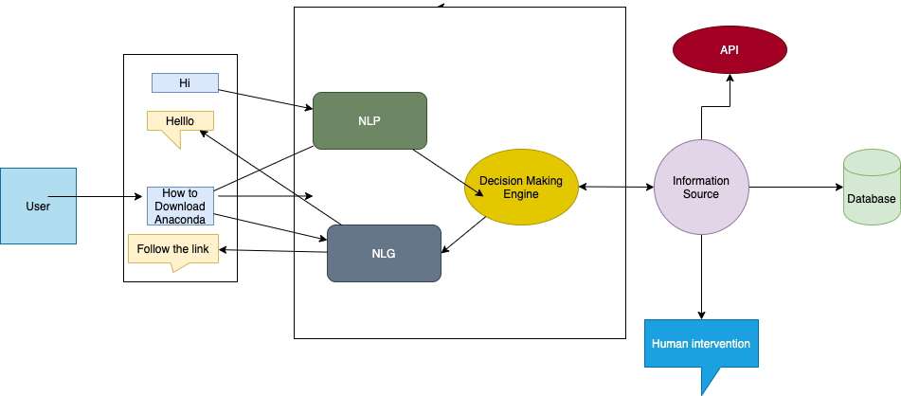

## **About natural language processing**

NLP is a form of artificial intelligence (AI) that allows chatbots to understand and respond to the user’s message. Artificial intelligence is the science of making machines and computers do tasks that require human intelligence. So NLP essentially falls into the ocean of AI and plays a super important role when it comes to building chatbots. Without NLP, chatbots wouldn’t be able to differentiate between certain phrases. For example, we need NLP to help give context to the chatbot so that it understands the difference between “Hi” and “Bye.”

## **How does NLP work in a chatbot?**

In order for the chatbot to understand the user’s message, it needs to somehow convert the unstructured human language to structured data that computers can interpret. When a user sends a message to the chatbot, it needs to use algorithms to get meaning and context from every sentence to collect data from them. This process is called natural language understanding (NLU), and it’s a subset of natural language processing. It consists of interpreting the user’s message by extracting important and relevant details from it.

A way to extract the essential parts of a sentence is to differentiate between the entities and the intent. The intent of a sentence is the goal of the statement. What does the user actually want to achieve? For instance, if the message was, “When does the Ineuron office close in the evening?” The intent of the message is to know when the institute closes. An entity of a sentence is something that modifies or supports the intent. For instance, the entities of the question, “What are your closing hours on Tuesday?” are Tuesday and closing hours. An entity is basically anything that can be named (like place, person, name, or object).

The chatbot basically needs to recognize the entities and intents of the user’s messages. In order to do that, we need to build an NLP model for every entity for an intent. For example, we can build an NLP intent model for the chatbot to recognize when a user wants to know the opening hours of Ineuron. We can build an NLP entity model for the chatbot to recognize intent. We can then use these NLP models for the chatbot to offer the answer

The NLP process is a core part of the chatbot architecture and process, since it is the foundation for translating the natural human language to structured data.

**The chatbot process breaks down this way:**

1.) Let’s say you want to pursue one of the courses of iNeuron and you decide to use the help of a chatbot. You type in your request.  
2.) When you send a message to the chatbot, asking for details of course, the chatbot sends the plain text to the NLP engine.  
3.) The NLP engine, which uses natural language processing and NLU, converts the text message into structured data for itself. This is where the different NLP models come into play for extracting the intents and entities of the message.  
4.) The chatbot moves the data that was collected (the intents and entities) to the decision-making engine.  
5.) The decision-making model derives a solid decision based on previous actions and results taken. (It makes a call to the database to make a decision.)  
6.) This is where the chatbot converts the decision data to text. Natural language generation (NLG) consists of converting data into plain text. Using NLG, the message generator outputs the message. This message is presented to the user in the form of a text message.

7) The decision engine can also send the message for human intervention if the query needs to be addressed by experts.